**Postman with Jenkins**

**1. Run a collection through runner in postman**

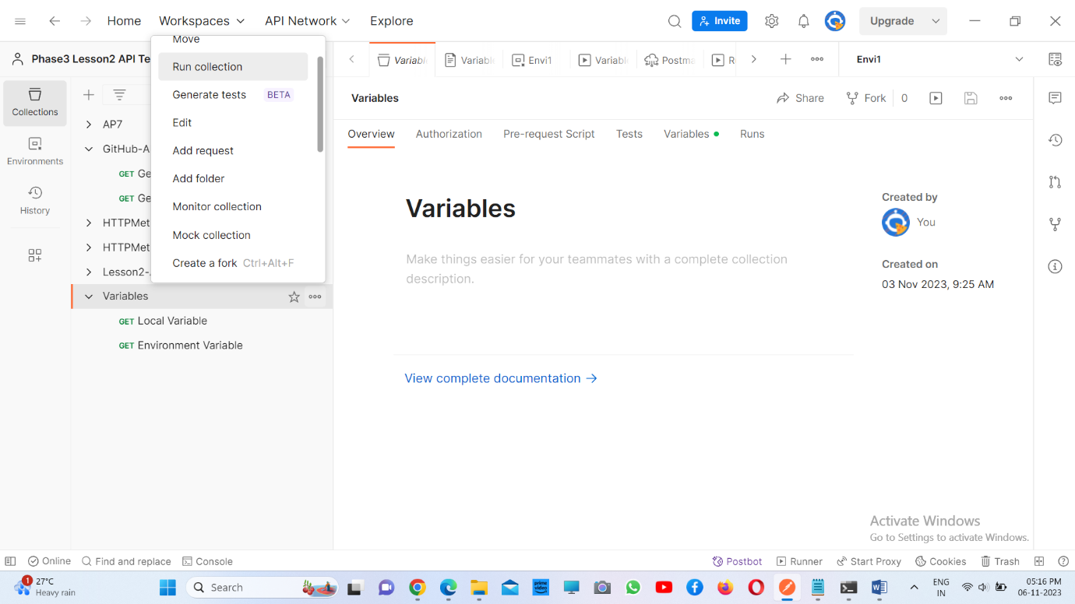

**2. Choose ‘Automate runs via CLI’ and click on ‘Configure command’ at the end**

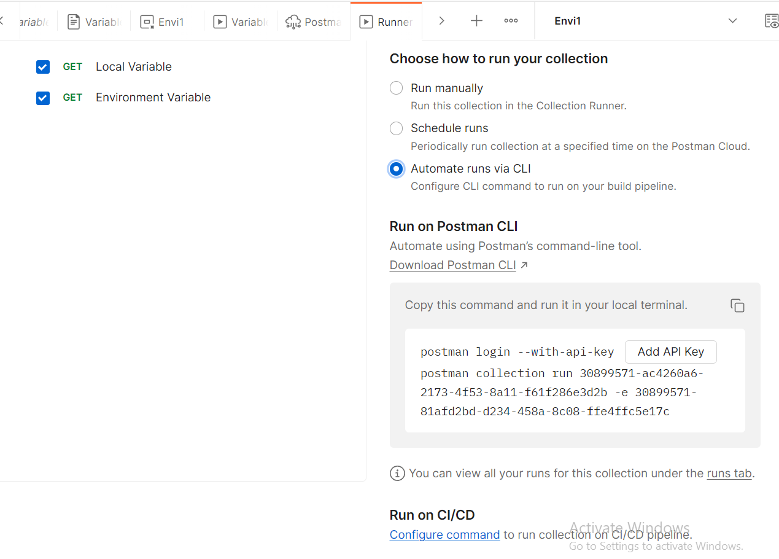

**3. Select Operating System as Windows and copy the CI/CD pipeline code**

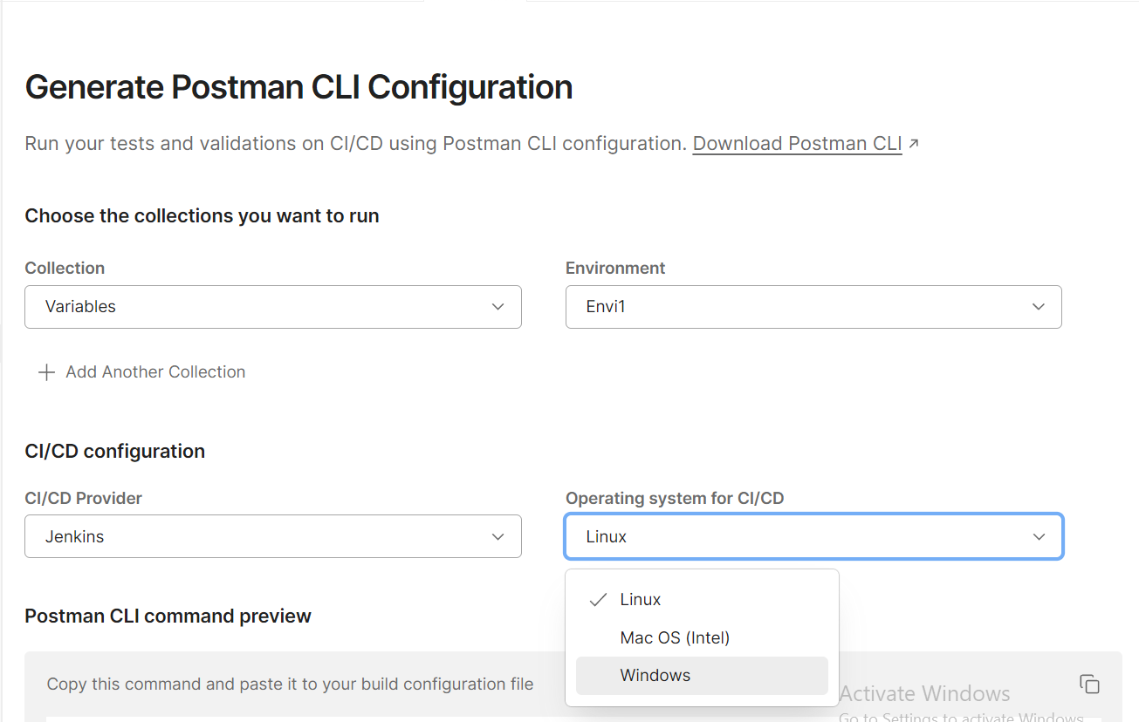

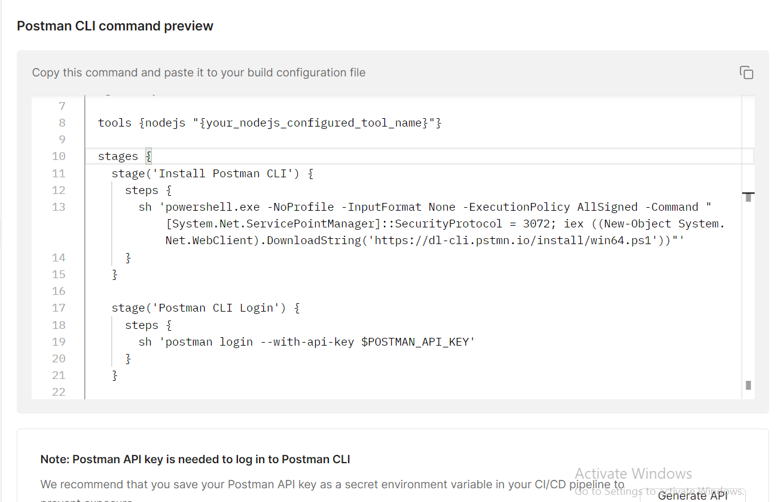

**3. Log in to Jenkins, Go to Manage Jenkins and plugins**

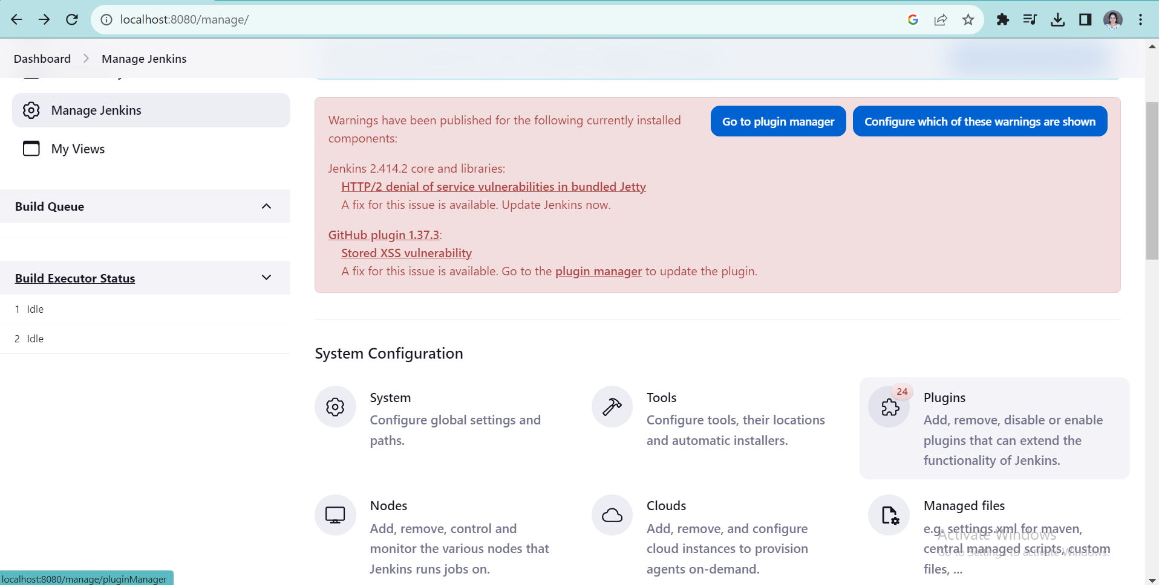

**4. In available plugins, install nodejs plugin and make sure it is enabled in installed plugins**

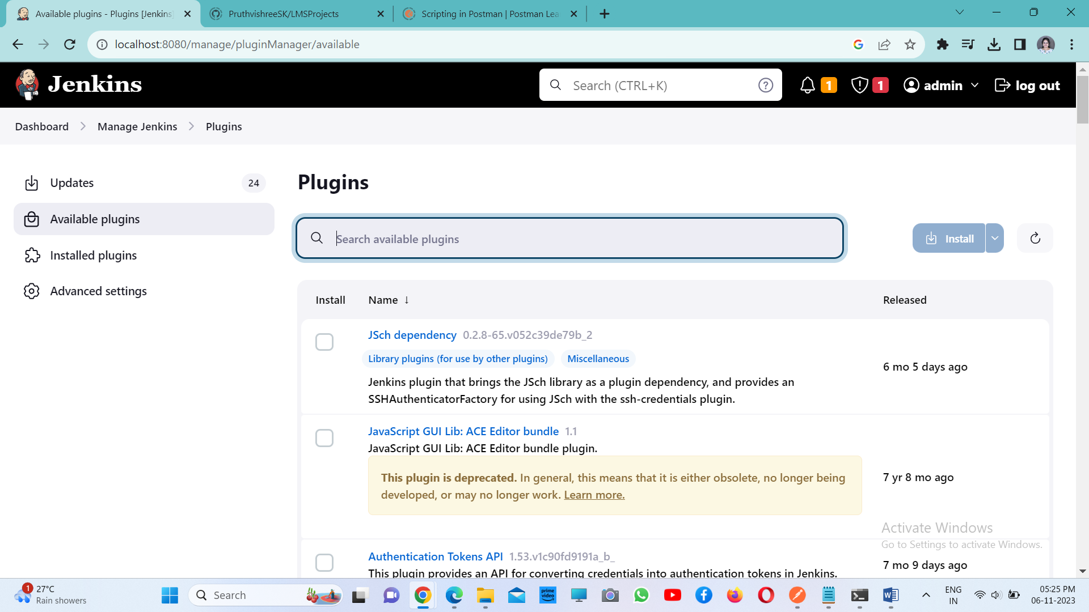

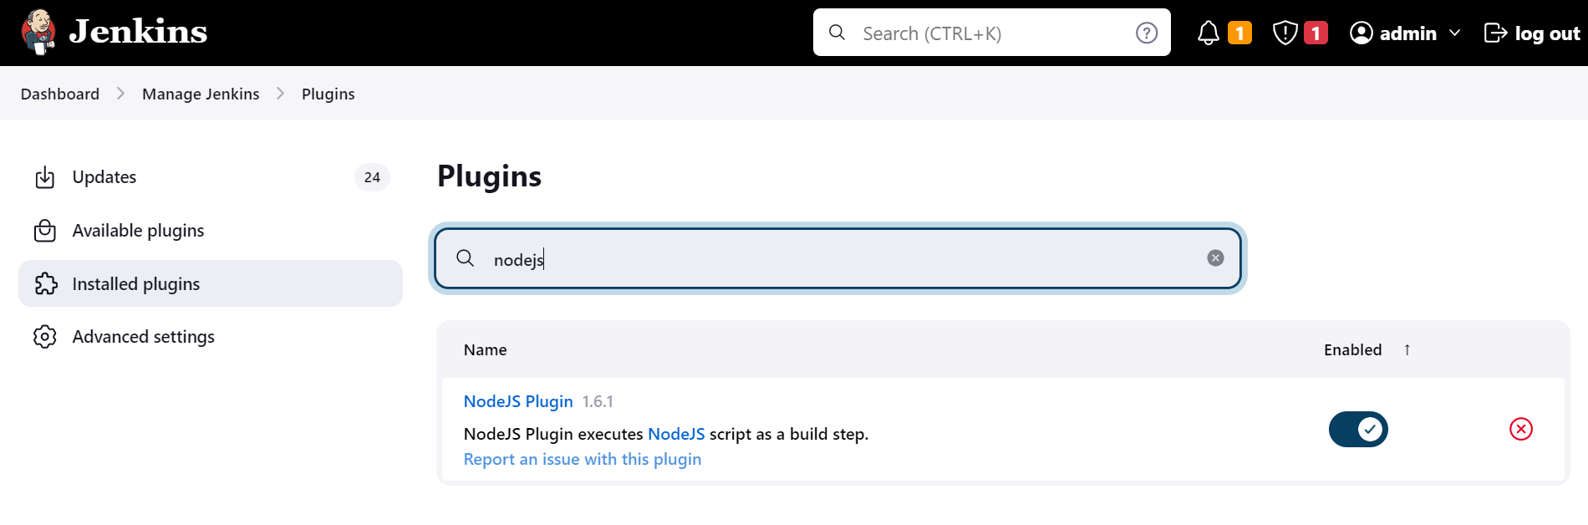

**5. Go to dashboard, add a new item of type pipeline**

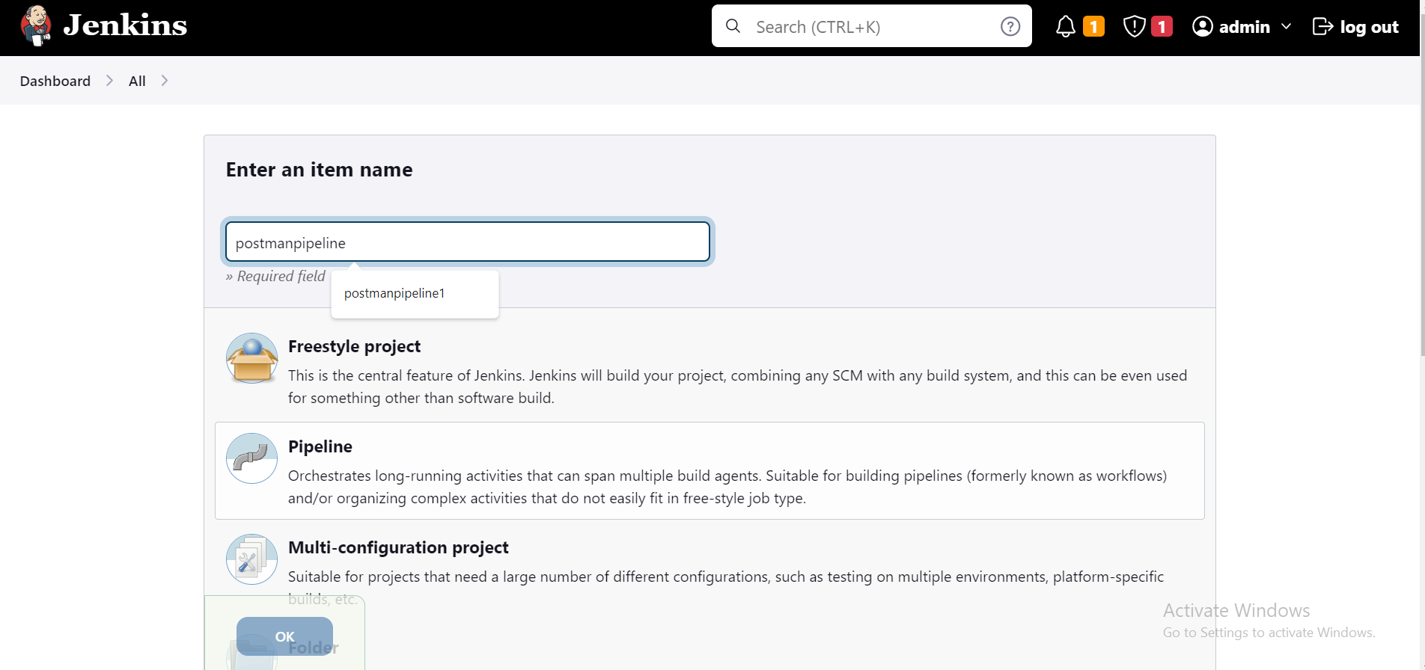

**6. Go to configure and paste the pipeline script in pipeline section**

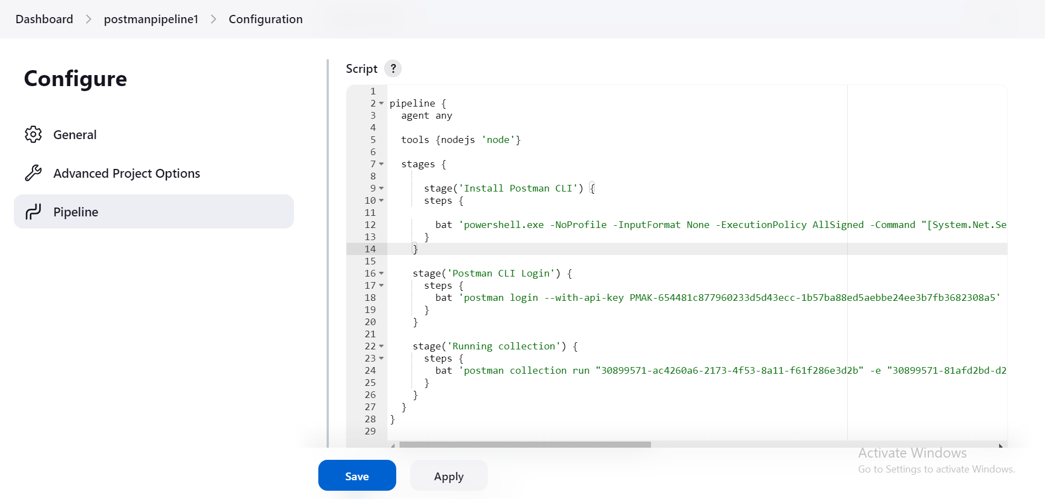

**7. Save and click on Build now to observe console output**

